**The UDP Band Map**

Aki Yoshida JA1NLX

## 1. 0 GENERAL

Logger32 has a function to receive and display decoded callsigns with some additional information on the UDP BandMap and send a reply message to JTDX or WSJT-X. JTDX or WSJT-X works as if the callsign is double-clicked on it's window when it receive reply message.. This data is distributed via UDP (User Datagram Protocol) approximately every 15 seconds (FT8 Mode) or 60 seconds (JT65, JT9 Mode etc) by WSJT-X/JTDX program. The reply message is sent via UDP.

When the QSO is logged in WSJT-X/JTDX then Logger32 will log this QSO via UDP and sends this QSO automatically as a DX Spot if you want. See the Setup Menu section in details.

**Note 1**: The UDP BandMap and JTAlert program can not run at the same time.

**Note 2**: Use TCP or UDP for logging.

**Note 3:** 77 bit protocol which will be implemented in WSJT-X ver 2.0 is supported.

**Note 4:** WSJT-X only responds to one type of UDP Reply Message - "Answer this CQ call".

## 2. WSJT-X/JTDX SETTINGS

### 2.1 Settings in WSJT-X program

Look for UDP Server group. You should leave the default value like this.

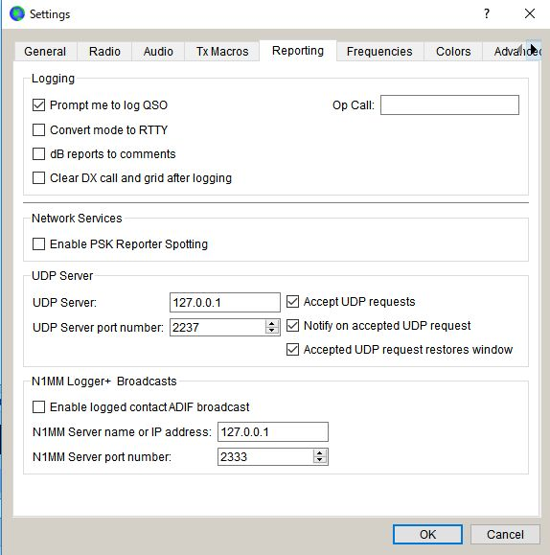

UBM_1

### 2.2 Settings in JTDX program

Look for UDP Server group. You should leave the default value like this.

If you do not use External logbook connection then uncheck "Enable data transfer to external log"



UBM_1

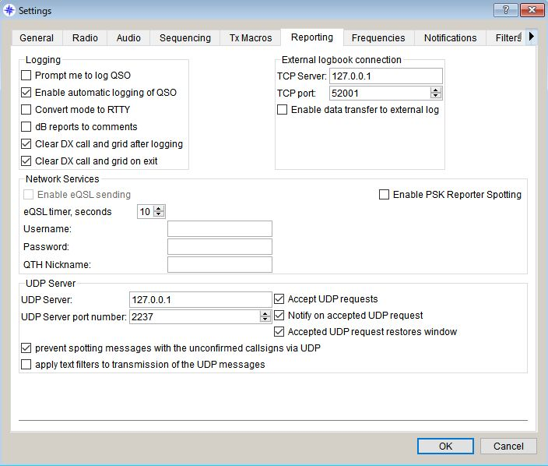

UBM_2

## 3.0. LOGGER32 SETTINGS

The callsign highlight colors and DXCC award tracking information are displayed in UDP BandMap depend on the settings in "DX Spot highlight color" and "Setup phone/digital modes"

Settings for me to operate FT8, JT9 and JT65 below.

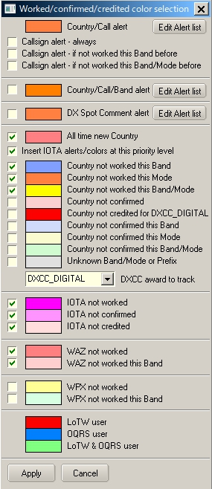

UBM_3

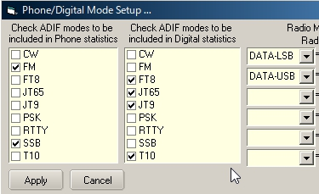

UBM_4

With this settings Worked/confirmed Window looks like below.

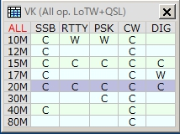

UBM_4A

## 4. OPERATION (1)

* + Run WSJT-X or JTDX. Do not run JTAlert at same time.
  + Run Logger32
  + Right click on "UDP" in the lower status bar. Click "Open UDP BandMap"

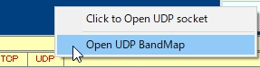

UBM_5

When WSJT-X or JTDX decode callsigns these callsigns are displayed in the UDP BandMap.

WSJT-X or JTDX, Band and Mode are displayed in title bar. Band and Mode are derived from WSJT-X or JTDX.

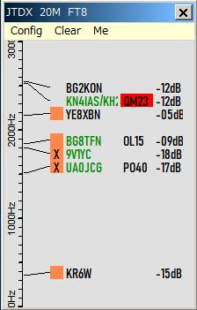

UBM_6

Click "X" to close UDP BandMap.

## 5.0 MENU

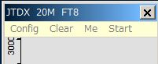

UBM_6A

Click "X" to close UDP BandMap and WSJT-X/JTDX if opened.

## 5.1 Config

Select the Config menu item.

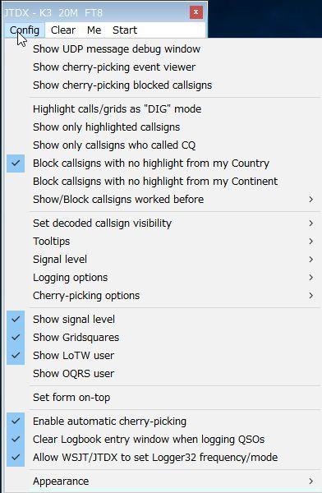

new UBM_6AB

There are a lots of options. You may choose whatever you prefer now.

If you want to see highlight colors and tooltips information based on every mode then un-check "Highlight callsigns as "DIG" mode" This option works for displaying "QSOd B4" mark as well.

Sub menu for Logging options



UBM_6AC

If you want to use direct logging then check ~~"Allow QSO automatic logging".~~ “Allow automatic WSJT/JTDX QSO logging” ~~TheVFO~~ The VFO frequency plus transmit tone frequency are written in the ADIF FREQ field and the VFO frequency plus receive tone frequency are writen in the ADIF FREQ_RX field in the Logbook. Logger32 calculates and logs the ADIF DISTANCE field.  Look at logged QSO ~~with W0MB~~ below. Gridsquare and Distance are logged only if there are decoded.

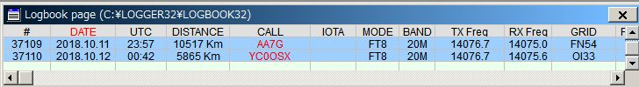

new UBM_6B

Following data entered into the Logbook Entry Window is logged with the UDP logging information if not already in the UDP logging message.

TX_PWR, QTH, ADDRESS, COMMENT, NAME, STATE, and CNTY.

If you want to set the Logger32 frequency/mode from WSJT-X/JTDX then check “Allow WSJT/JTDX to set frequency/mode” Logger32 radio port must be closed. See paragraph 5.4 Start for related explanation and paragraph 5.0 Band Mode Selection Setup in the Logbook Entry Window section.

If you want to see the signal level then check "Show signal level" and click ”Signal level” to select the signal level type, SNR or S units.

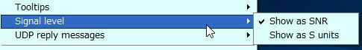

UBM_6C

If you want to see the Gridsquare then check "Show Gridsquares".

Sub menu for “Show/Block callsigns worked before”

If you want to block callsigns QSOd this band/mode B4 then check like this.

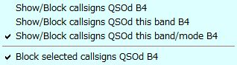

UBM_6D

Sub menu for "Set decoded callsign visibility"

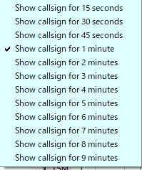

UBM_8

Sub menu for "Tooltips"



UBM_9

Sub menu for ~~“UDP reply messages”~~ “Cherry-picking options”

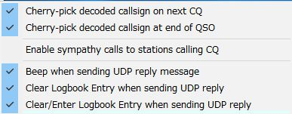

UBM_9A

Sub menu for "Appearance"

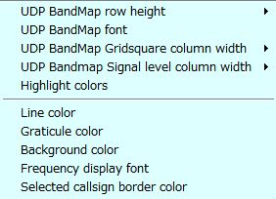

UBM_10

UDP BandMap Gridsquare and Signal Level column width can be selected repsectively.

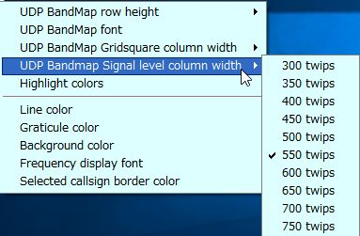

UBM_10A

Click "Highlight colors" to configure Gridsquare highlight colors and UDP BandMap text color. If you prefer to see bold text for callsign who have called CQ then check "Show bold text who have called CQ"

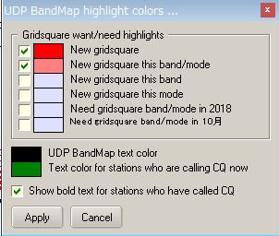

new UBM_11

Sample below.　The stations who are calling CQ now are displayed in Green text, the stations who have called CQ are displayed in Black/bold text and the stations who are working other stations are displayed in Black text.

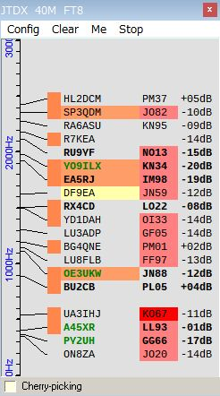

new UBM_11A

## 5.2. Clear

This clears UDP BandMap.

## 5.3. Me

This opens the Calling Me UDP BandMap and hide this item in the menu bar. See details in paragraph [Operation(4)](#8.0._OPERATION(4)).

## 5.4. Start

Default item is WSJT-X and/or JTDX if these programs are installed in your PC. You may add another shortcut using unique radio name. See details in WSJT-X/JTDX Help.

If you start WSJT/JTDX from Start menu, the Logger32 radio serial port is closed before the digital application starts. WSJT-X/JTDX caption is replaced by shotcut caption + “& Logger32”and “X”is hidden in the title bar.



UBM_11AB

Then if you close the digital application from Logger32 (either by UNchecking the START menu, or by closing the UDP BandMap), the Radio serial port is automatically reopened.

If the Logbook Entry Window stays populated, Logger32 makes theRadio be aligned with the Logbook Entry Window (spotted) infomation.

If the Logbook Entry Window is empty/wiped, Logger32 sets the Radio to pre-WSJT-X/JTDX opening state.

If you click WSJT-X, WSJT-X starts, then if you click JTDX, WSJT-X close and JTDX starts.

If WSJT-X/JTDX opens with Radio in split mode then Radio turns in split off mode. You need to add $SplitVisualAlertsOff$$clearlog$ as “before starting WSJT/JTDX” macro.

**Note: DO NOT TRY TO RUN WSJT-X/JTDX IN XP COMPATIBLE MODE, OTHERWISE IT DOES NOT WORK CORRECTLY.**

## 

UBM_11B

Click “Setup shortcuts” to add/edit shortcut and put commands/macros for Radio 1/2 if you like to execute before starting WSJT-X/JTDX and after closing WSJT-X/JTDX.　Macros for Radio Control Panel can be used in this table as well.

Example macros below are Split OFF, Power 50W, NB OFF/ NR OFF (Radio2-IC7300) for before starting WSJT-X/JTDX and Power 100W for after closing WSJT-X/JTDX.

**Note:** It may take a few seconds to open WSJT-X/JTDX depending on “before starting WSJT-X/JTDX” command/macro, radio type and Logger32 polling interval.

## 

UBM_11C

## 6.0 OPERATION (2)

If you move mouse over callsign then tooltips appears.

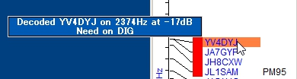

UBM_12

If you left-click any callsign then this callsign is transferred in Logbook Entry Window.

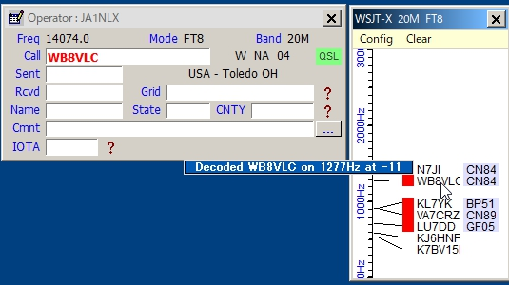

UBM_13

If you right-click any callsign then history of this callsign is displayed. (max 15 messages)

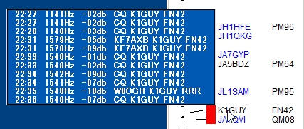

UBM_14

If you confugure various options properly then you see LoTW/OQRS user, QSO B4, highlighted callsign and Gridsquare.

When QSO is logged in WSJT-X/JTDX then Logger32 log this QSO via UDP if "Allow QSO automatic logging" is checked.

## 7.0 OPERATION (3)

Logger32 can send reply message to JTDX or WSJT-X for a manually selected callsign. When it receives reply message then it will transmit message corresponding to the reply message.

For JTDX following options should be checked and “AutoTX” should be turned ON.

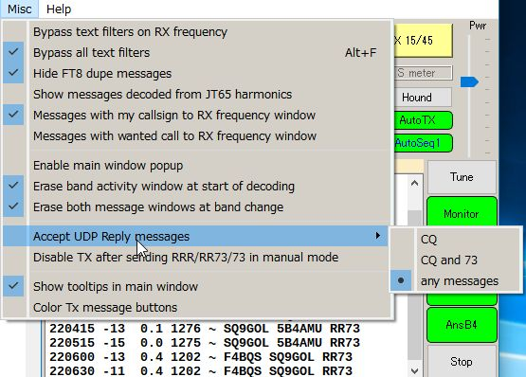

new UBM_14A

For WSJT-X Auto Seq should be checked and “Call 1st” should be unchecked.

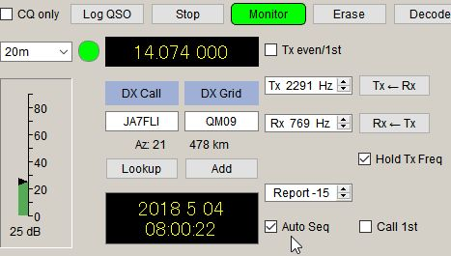

UBM_14B

The following options should be checked in the UDP BandMap Config menu. Uncheck “Call selected callsign at end of QSO” if WSJT-X is used.

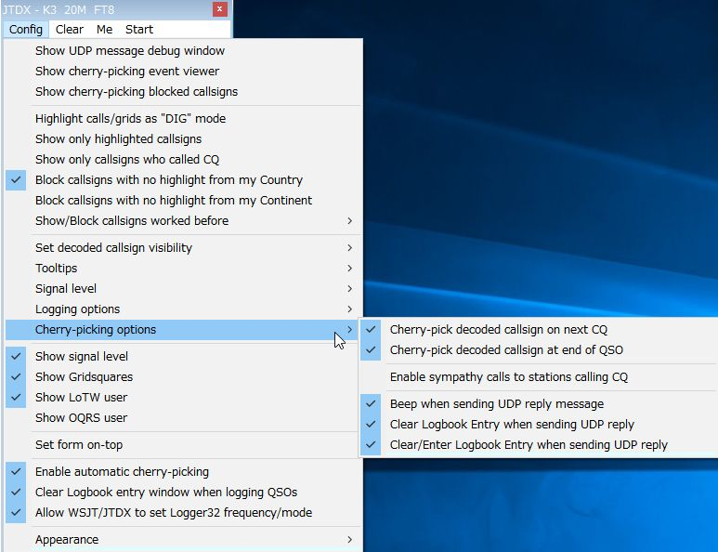

new UBM_14C

Click on any callsign you want to call. The callsign is surrounded by a box and transferred to the Logbook Entry Window. The box border color can be configured in “Config”, “Appearance”, “Selected callsign border color”.

## 

UBM_14D

When:

(a) The operator calls CQ on the next time slot, a reply message is sent to JTDX or WSJT-X and it will transmit a message calling him/her.

(b) The operator sends a message with 73 or RR73 or RRR, a reply message is sent to JTDX and it will transmit message calling him/her.

(c) If the operator replies to you then the box disappears.

-1 If the operator dose not reply to you then it tries max 5 calling cycles and the call is canceled.

-2 If there is nothing heard from the station for 90 seconds then the call is cancelled.

Note: For WSJT-X users, do not use this feature, otherwise you have unexpected result.

The Logbook Entry Window is cleared.

**8.0 OPERATION(4)**

###### Cherry-picking

Logger32 can send reply message to JTDX or WSJT-X for automatically selected callsign. When JTDX or WSJT-X receives reply message then it will transmit message corresponding to the reply message.

**Note:** JTDX allows reply message for CQ/73/RR73, however WSJT-X allows reply message only for CQ.

**Note:**

a)  It does not work duplicate QSOs on a Band/Mode

b)  It does recognize CQ, CQ DX, and CQ <your Continent>. All others are ignored.

c)  It does call DXCC highlighted callsigns (based on user configuration options in DX spot highlight color　table.

d) It does call stations with highlighted Gridsquares.(based on user configuration options in UDP BandMap highlight color table).It pickes highlighted callsigns or stations with highlighted Gridsquares at random.

e) It remembers the callsign of a station that drops his callsign in the middle of a QSO.  On completion of the current QSO (or attempted QSO), Logger32 automatically replies to the station that called.

To eanble Cherry-picking, click “Config” then check “Enable automatic cherry-picking” Status bar appears at bottom in UDP BandMap. Check “Cherry-picking” Check/Uncheck this option to turn Cherry-picking ON/OFF.

When Cherry-picking pick callsign, the callsign is displayed in status bar in Red color. When he send CQ/73/RR73 JTDX will call him automatically.

After 90 seconds Cherry-picking for the callsign ends and the callsign disppears.

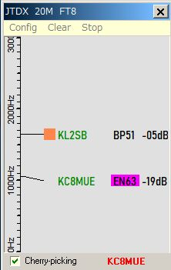

UBM_14DA

“Enable sympathy calls” option (see UBM_14C)

If this option is checked it calls any CQ caller at random even if he is not highlighted. The tooltip for the cherry-picked callsign is displayed like this.

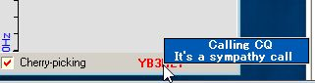

UBM_14DA1

“Show cherry-picking blocked callsigns” option

If you right-click on the area where cherry-picked callsign is displayed then you see another menu.

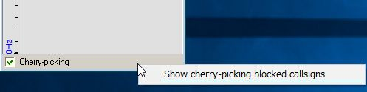

UBM_14DA2

Click “Show cherry-picking blocked callsigns” to show the table. Click “Wide” button.

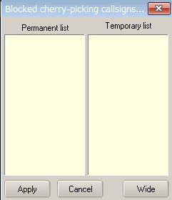

UBM_14DA3

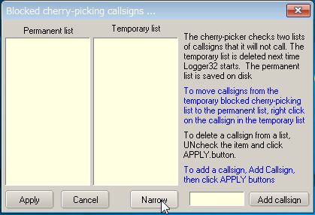

UBM_14DA4

See the text above. It explains how to add callsign you want to block and how it works.

**Note:** Right-click on “Cherry-picking” to show menu. If you prefer then check this option.

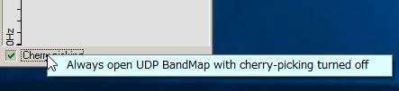

UBM-14DAB

The Cherry-picking event log is displayed in the Cherry-picking Debug window. To open the Cherry-picking Debug window click “Show cherry-picking debug window” in the Config menu.

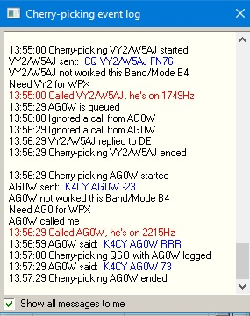

UBM_14DB

## 9.0. OPERATION(4) (5)

Click “Me” in the Menu to show the Calling Me BandMap. Only callsigns calling me are displayed in this window.

## 

UBM_14E

**For JTDX:**

It may be a little complicated because JTDX has various options for Auto Seq.　It is better to use following setup to use this functionality.

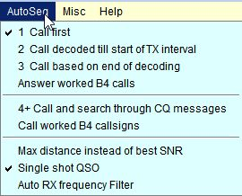

UBM_14F

When you call CQ and receive multiple replies, these callsigns are displayed in Calling Me BandMap. JTDX will transmit message automatically for the first decoded callsign. When you finish this QSO, click another callsign. JTDX will transmit message for this callsign.

**For WSJT-X:**

Set options like pic UBM_14B. When you call CQ and receive a reply, callsigns are displayed in the Calling Me BandMap. Click any callsign you want to answer. WSJT-X will transmit a message for this callsign.

If you move the mouse over a callsign thena tooltips appears.

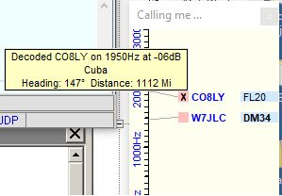

UBM_14G

## 10.0. TIPS

If you have "Show only callsigns calling CQ" and "Show only highlighted callsigns" checked then the only station that are highlighted and calling CQ will show.

The BLOCK COUNTRY and BLOCK CONTINENT options look for a Country/Continent match with the Logger32 Current Operator.  If you have the Logger32 operator set to "At the Beach" or "Club Station" or something other than the callsign of where you are operation, the results will be unpredictable.

Try to change settings of "DX Spot highlight colors" in DX Spot Window and settings of "Setup phone/digital modes" in Tools menu. It affects the way to display highlight colors and tooltips in UDP BandMap.

The Debug window is very useful to check problem. Click "Show debug window" in Config menu to show debug window. The Reply message is displayed in Red text.

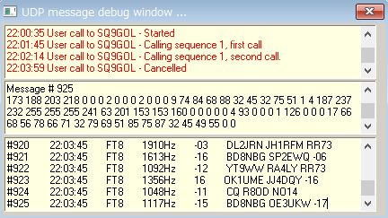

new UBM_15